Order Of Service

Singing: Psalm 150—CW page 122

Reading: Psalm 24

Opening Hymn: TLH 604

Reading: I Corinthians 15:51-58

Request Hymn: CW Supplement 716

Reading: Mark 3:31-35

Sermon Hymn: TLH 605

Sermon Text: Luke 13:22-30

The Shut Door

Prayer

The Apostles’ Creed, TLH page 12

Holy Communion

The Lord's Prayer

The Blessing

Closing Hymn: TLH 46

************
Bible Study: Lambs: Dog
Sheep: Philippians
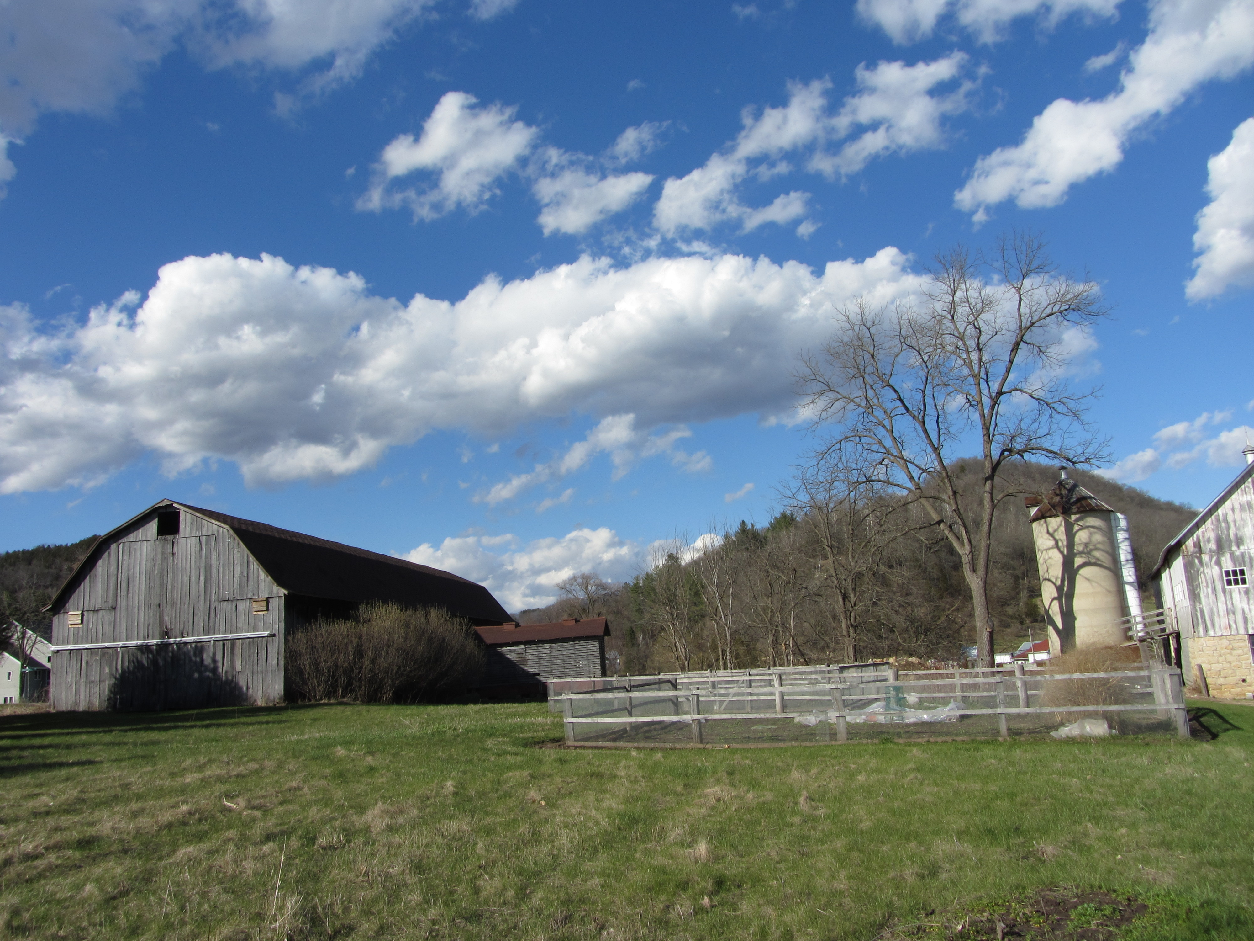

Spring In The Valley

Water
Of
Life

29 May 2022

W A T E R O F L I F E

Independent Christian Church—Conservative Lutheran Doctrine

Worship Service: 9:30 a.m.

Larry Cooper, Pastor E-Mail address:
111 N. Ridge Road lcooper@wateroflife.cc
Coon Valley, WI 54623 Web Site:
www.wateroflife.cc

* * * * * * * * * * * * * * * * * * * * * * * * * * *

Sermon Text: Luke 13:22-30

The Shut Door

* * * * * * * * * * * * * * * * * * * * * * * * * * *

22 And he went through the cities and villages, teaching, and journeying toward Jerusalem.
23 Then said one unto him, Lord, are there few that be saved? And he said unto them,
24 Strive to enter in at the strait gate: for many, I say unto you, will seek to enter in, and shall not be able.
25 When once the master of the house is risen up, and hath shut to the door, and ye begin to stand without, and to knock at the door, saying, Lord, Lord, open unto us; and he shall answer and say unto you, I know you not whence ye are:
26 Then shall ye begin to say, We have eaten and drunk in thy presence, and thou hast taught in our streets.
27 But he shall say, I tell you, I know you not whence ye are; depart from me, all ye workers of iniquity.
28 There shall be weeping and gnashing of teeth, when ye shall see Abraham, and Isaac, and Jacob, and all the prophets, in the kingdom of God, and you yourselves thrust out.
29 And they shall come from the east, and from the west, and from the north, and from the south, and shall sit down in the kingdom of God.
30 And, behold, there are last which shall be first, and there are first which shall be last.



